BHARAT SHRINIVAS HEGDE
CSE 3D
1BM25CS413-T (Diploma)

LAB PROGRAM 3A
WAP to simulate the working of a queue of integers
using an array. Provide the following operations: Insert,
Delete, Display
The program should print appropriate messages for queue
empty and queue overflow conditions

Code:
#include <stdio.h>
#define MAX 5
int queue[MAX];
int front = -1, rear = -1;

void insert(int item) {
if (rear == MAX - 1) {
printf("\nQueue Overflow\n");
} else if (front == -1 && rear == -1) {
front = rear = 0;
queue[rear] = item;
} else {
rear++;
queue[rear] = item;
}
}

void delete() {
if (front == -1 || front > rear) {
printf("\nQueue Underflow\n");
} else {
printf("\nDeleted element: %d\n", queue[front]);
front++;
}
}

void display() {
if (front == -1 || front > rear) {
printf("\nQueue is Empty\n");
} else {
printf("\nQueue elements: ");
for (int i = front; i <= rear; i++)
printf("%d ", queue[i]);
printf("\n");
}
}

int main() {
int choice, item;
while (1) {
printf("\n1. Insert\n2. Delete\n3. Display\n4. Exit\nEnter your choice: ");
scanf("%d", &choice);
switch (choice) {
case 1:
printf("Enter item: ");
scanf("%d", &item);
insert(item);
break;
case 2:
delete();
break;
case 3:
display();
break;
case 4:
return 0;
default:
printf("Invalid choice!\n");
}
}
}

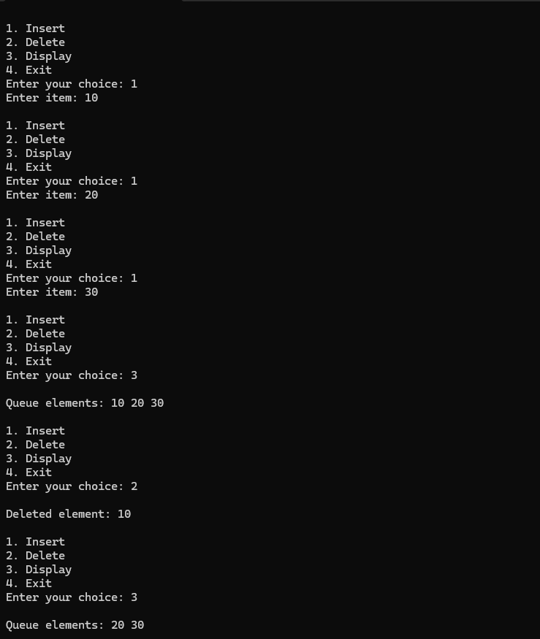
Output:

